# Principle 1: Know your user.

What is it? Design with your end user demographic in mind.

**How was it implemented by**: Mouse input, Touch screen, and Voice control. Three different ways for Users to open the Apps.

**Supporting Evidence:**

1. Mouse Setting  
   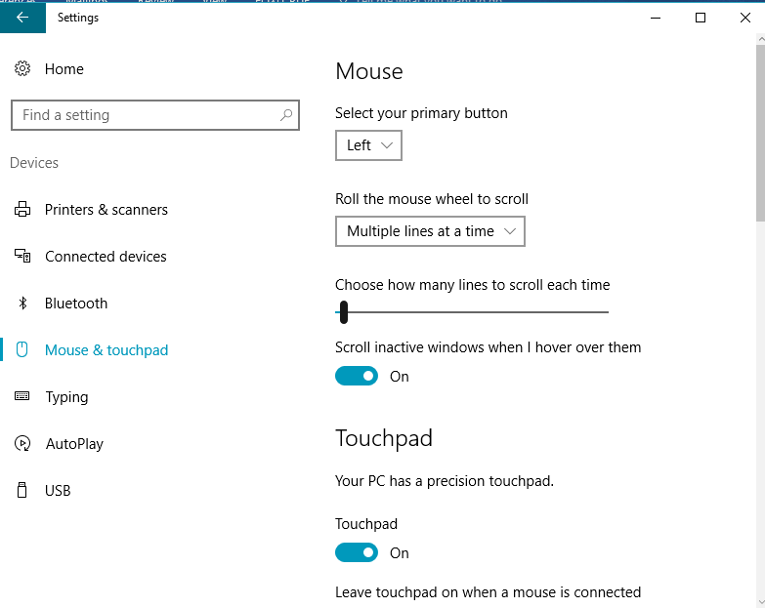
2. Touch Screen Setting

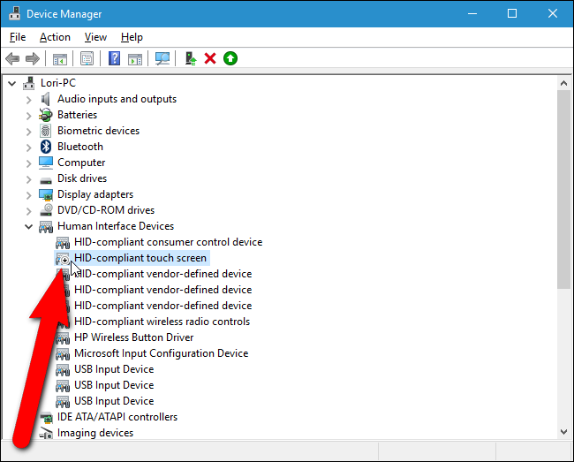

1. Voice control

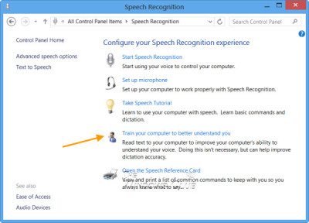

# Principle 2: Make Affordances.

What is it? Let your users know what you can do in the UI.

How was it implemented? Uses GUI instead of Command Line.

**Supporting Evidence:**

# Principle 3: Map Functionality.

What is it? Domain -> Range hinting.

How was it implemented? Excel quick formatting toolbar.

Supporting Evidence:

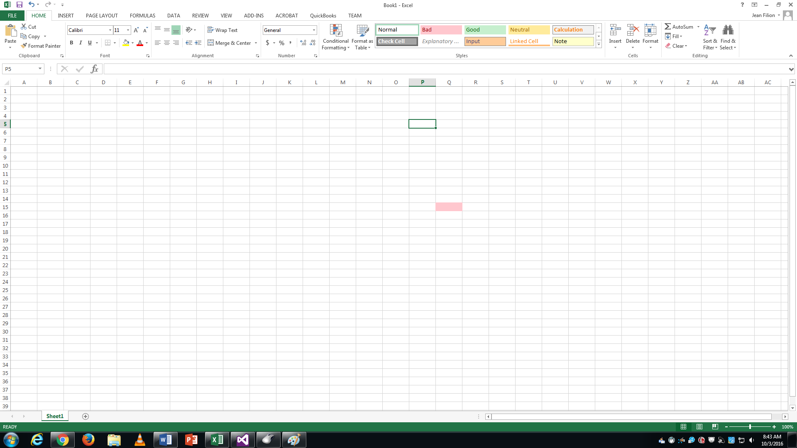

# Principle 4: Feedback.

What is it? Each time a user does something, system lets him know.

How was it implemented? If you copy a file, progress bar.

Supporting Evidence:

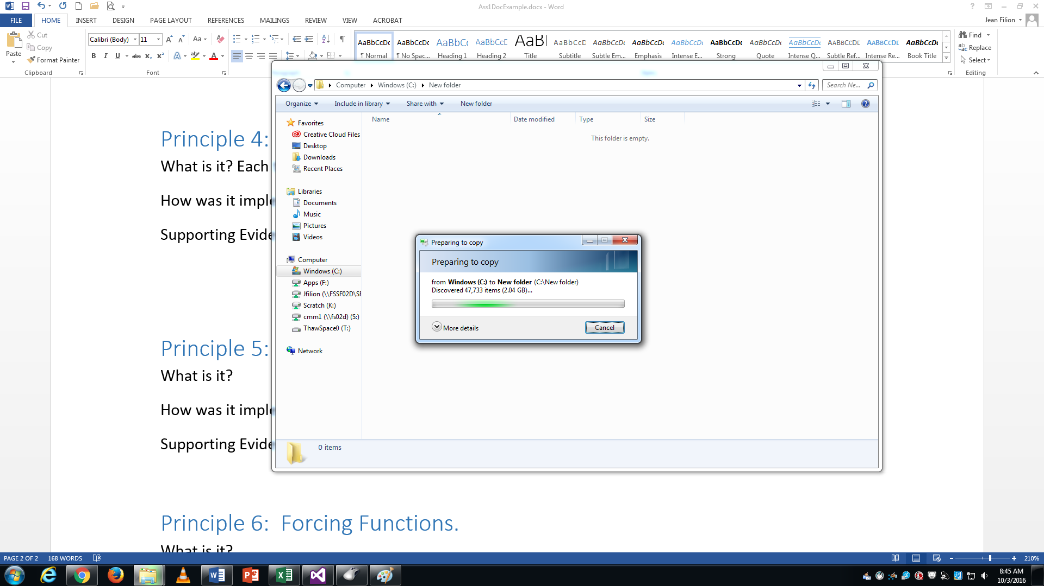

# Principle 5: Use Metaphors.

What is it? Represent a process by referencing other things.

How was it implemented? Graphical symbols such as speaker icon.

Supporting Evidence:

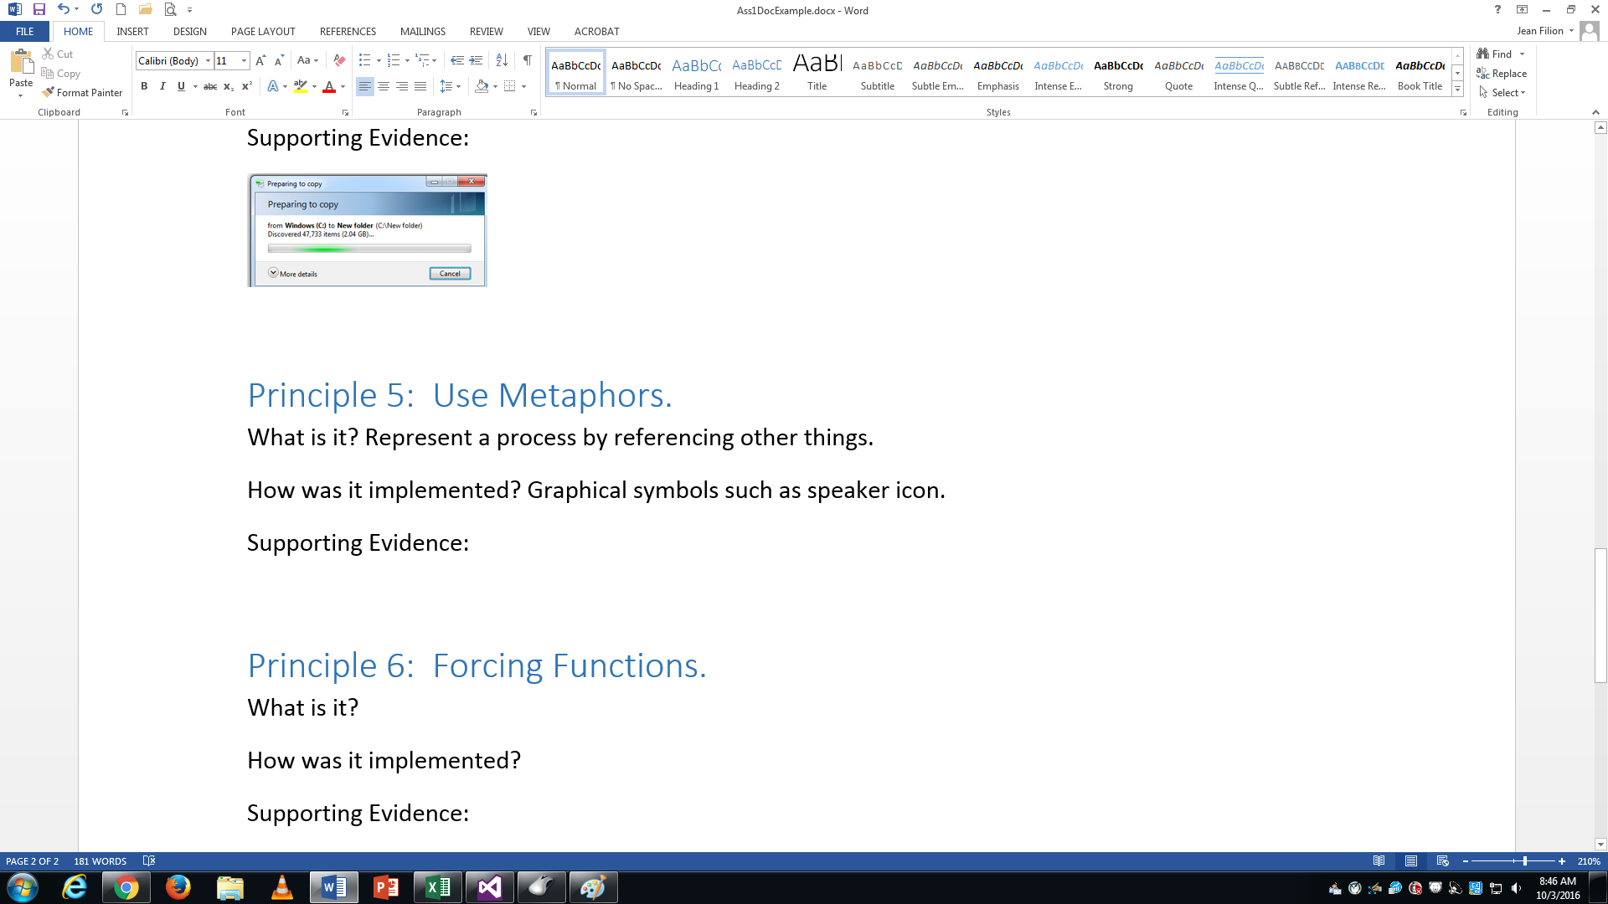

# Principle 6: Forcing Functions.

What is it? Prevent the user from making mistakes.

How was it implemented? Word->Page Layout Tab disabled icons.

Supporting Evidence:

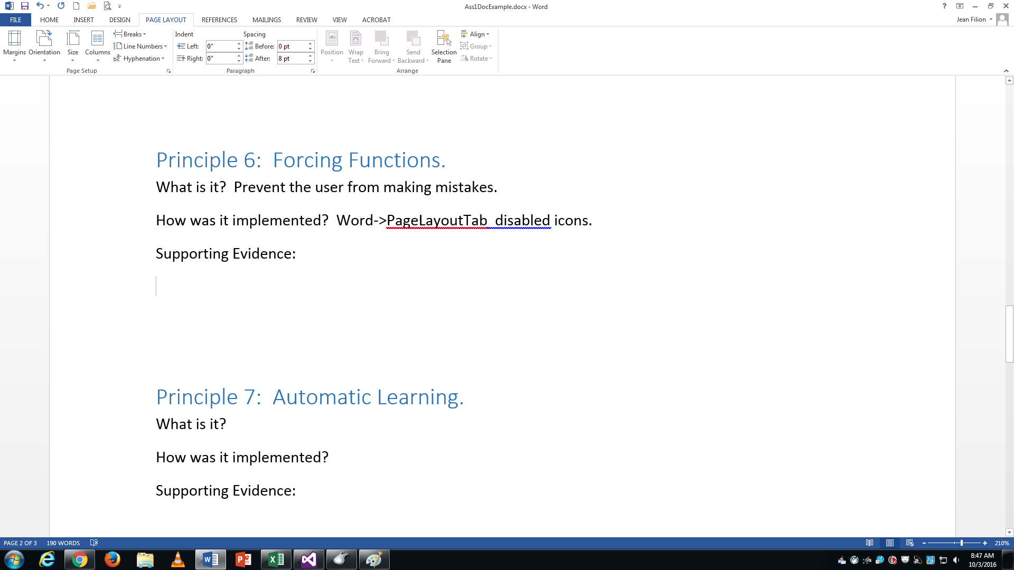

# Principle 7: Automatic Learning.

What is it? Use repetitive patterns in UI design.

How was it implemented? File explorer, several levels of a tree structure shown the same way as you drill down.

Supporting Evidence:

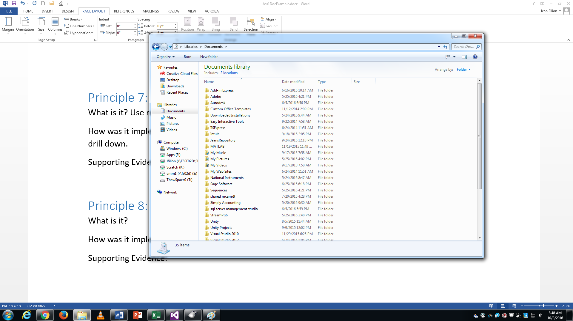

# Principle 8: Context + Detail.

What is it? Give enough details to do the task also give him clues as to where he is in the bigger picture.

How was it implemented? Status Bar num pages in a document.

Supporting Evidence:

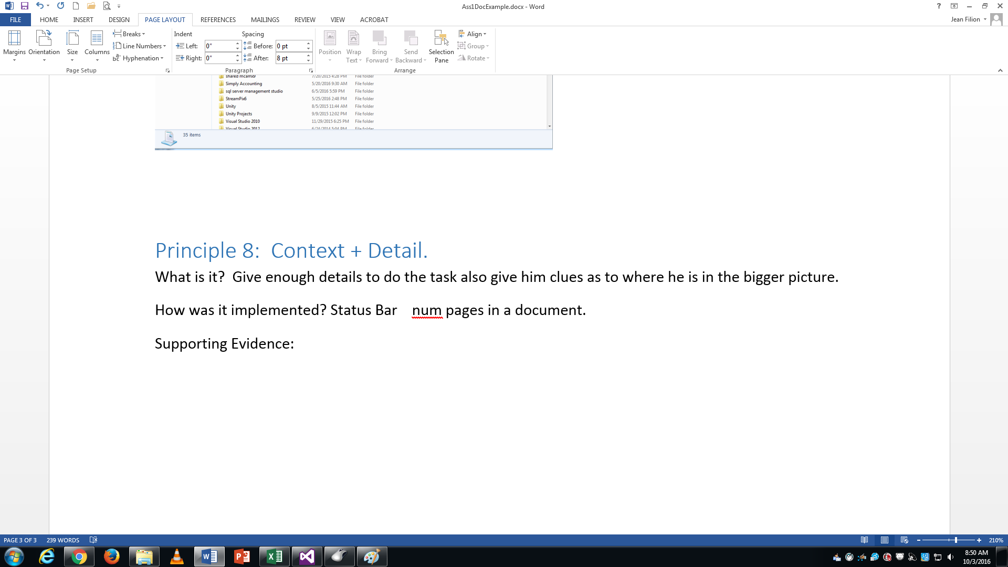

# User Interface Guideline Implementation (Case Study):

1 What is the Guideline: Access functionality between multiple windows.

Supporting Evidence of it being implemented:

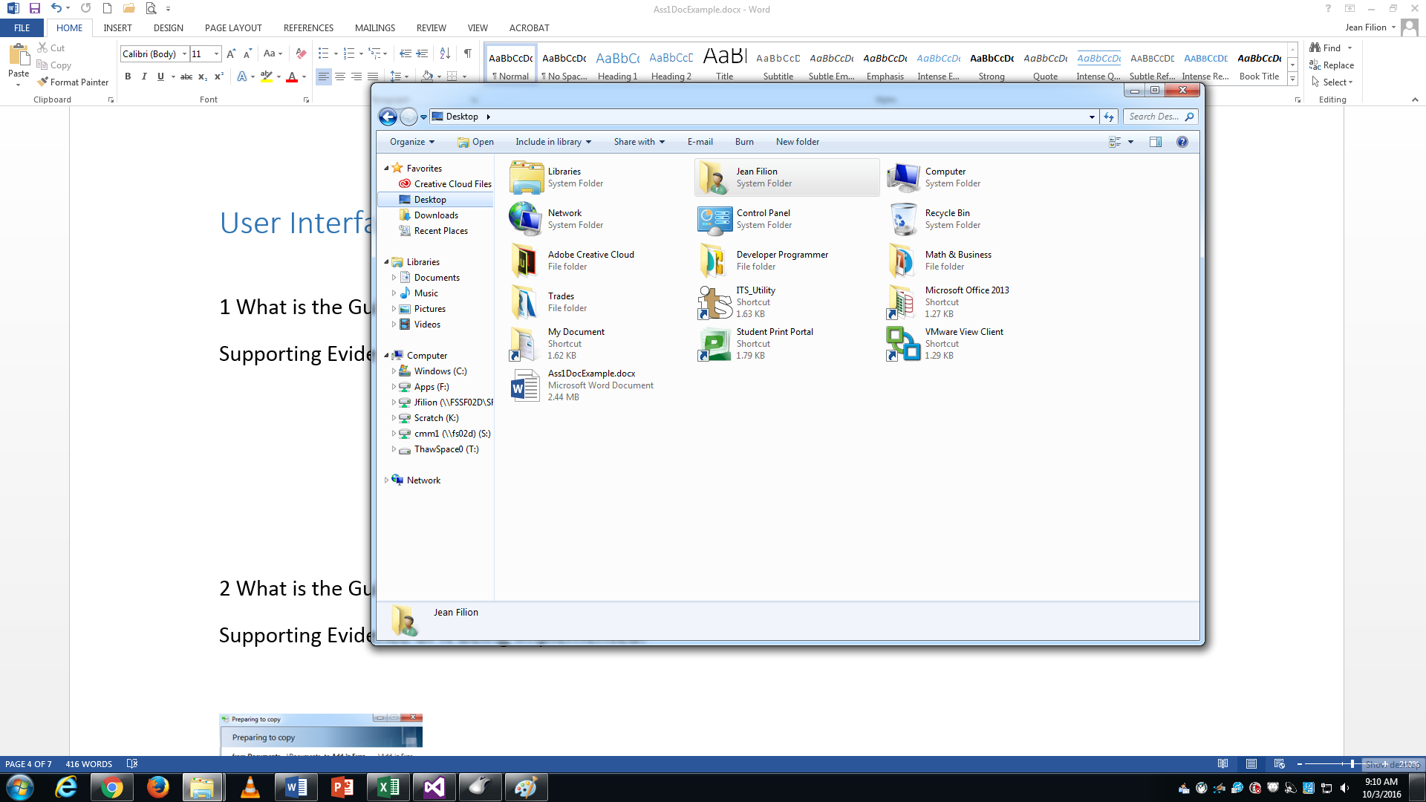

2 What is the Guideline: Progress bars. Use them to show approx. completion.

Supporting Evidence of it being implemented:

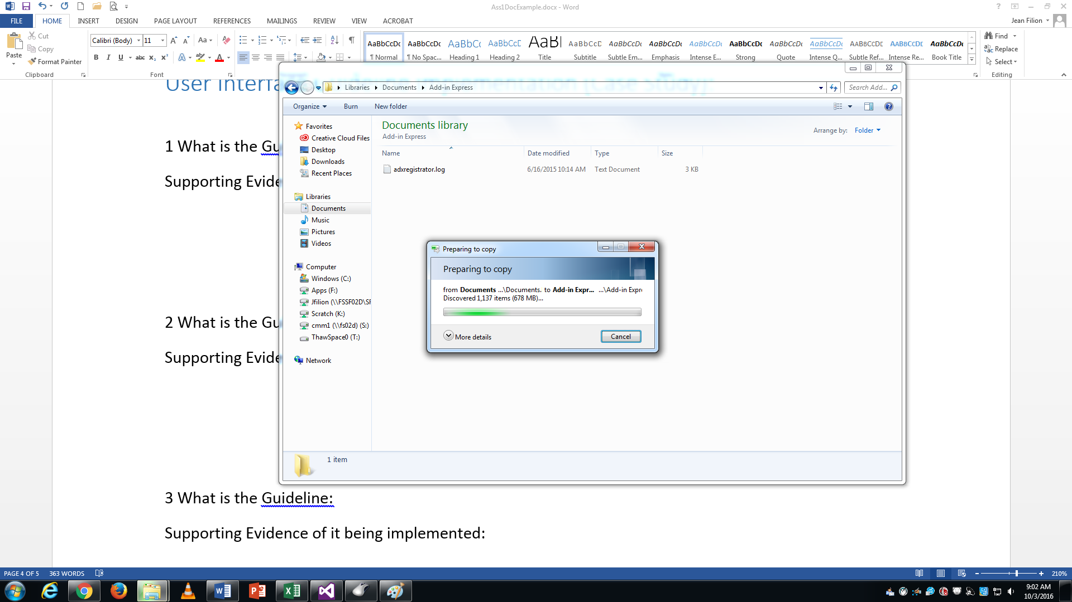

3 What is the Guideline: Use mouseover effects to show that an element is actionable.

Supporting Evidence of it being implemented:

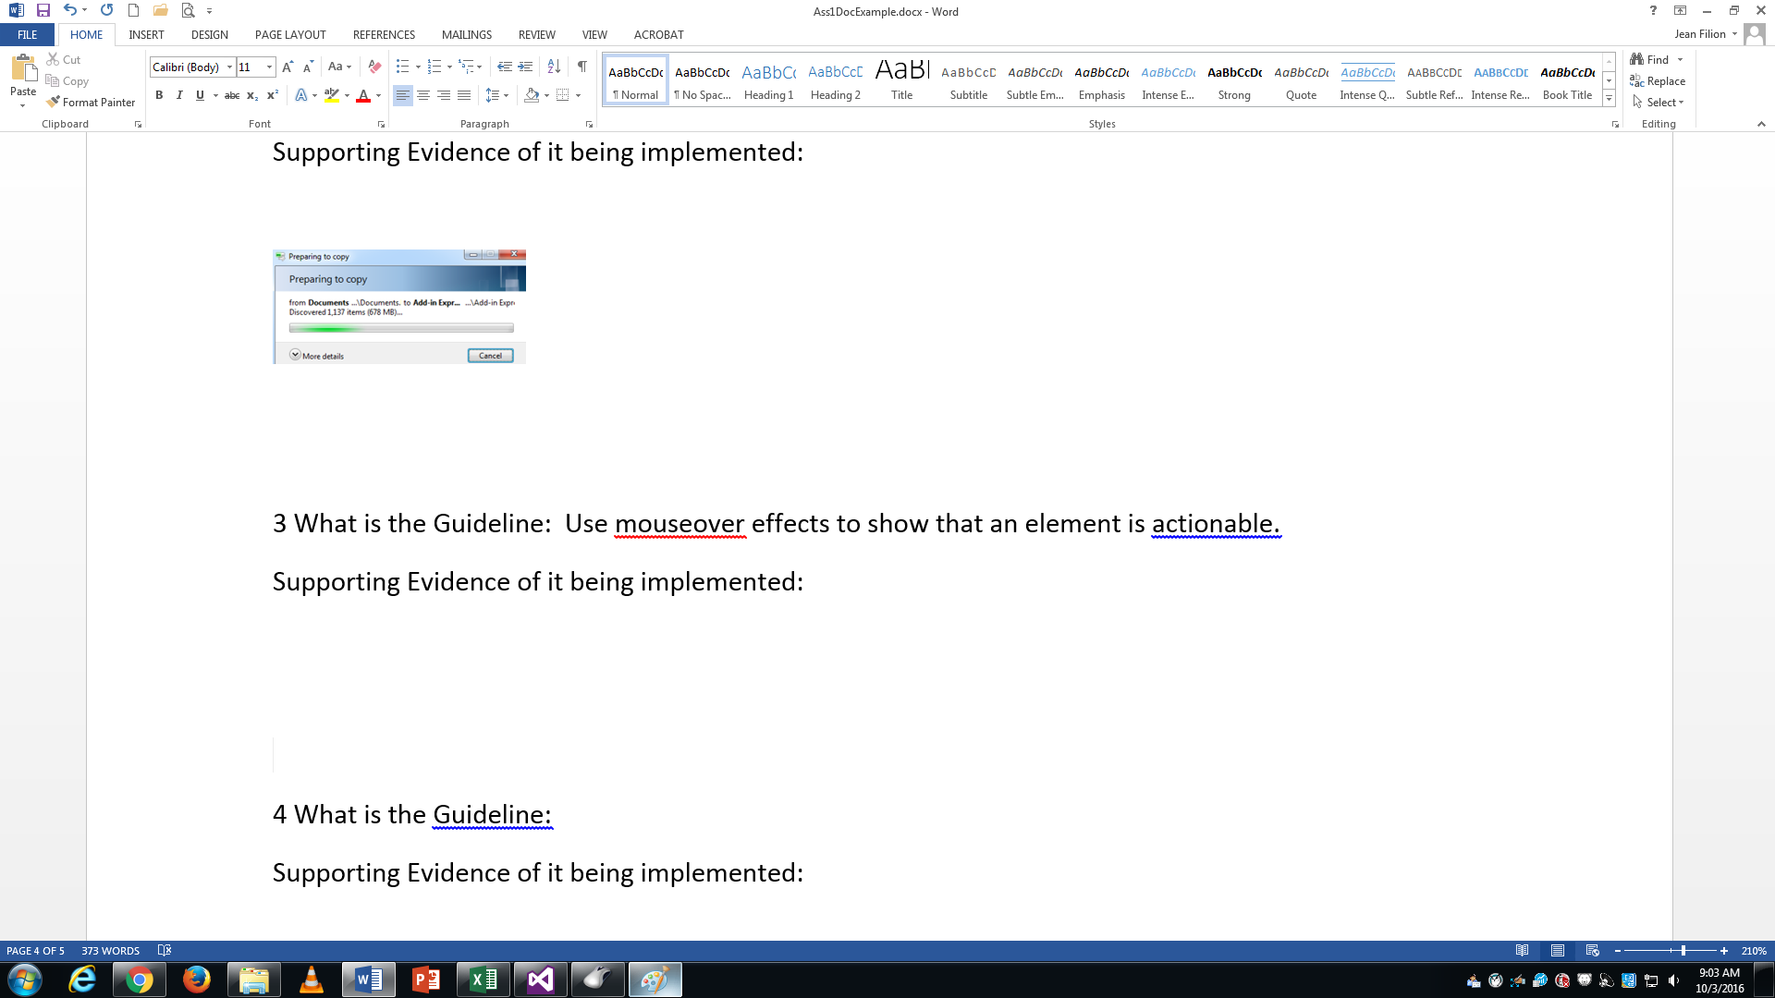

4 What is the Guideline: Use text to provide explanations.

Supporting Evidence of it being implemented:

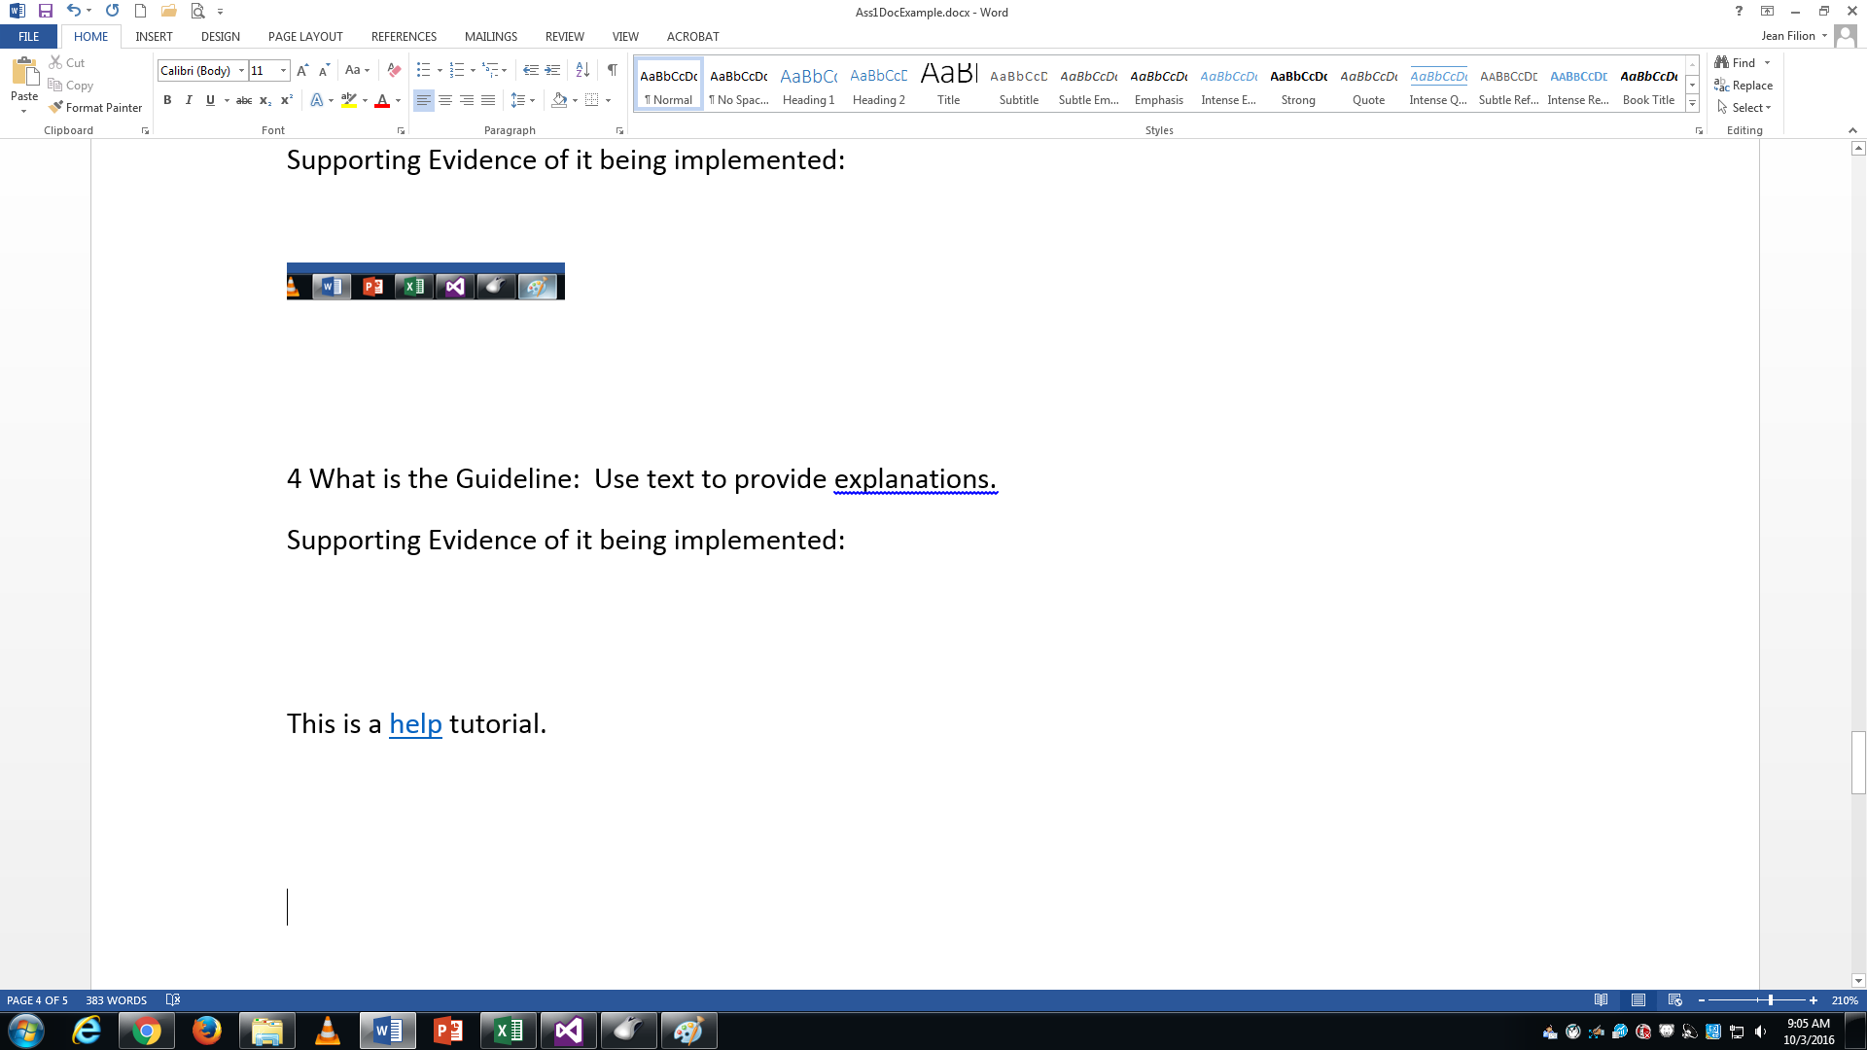

5 What is the Guideline: It should be a pleasure to see, and be responsive.

Supporting Evidence of it being implemented:

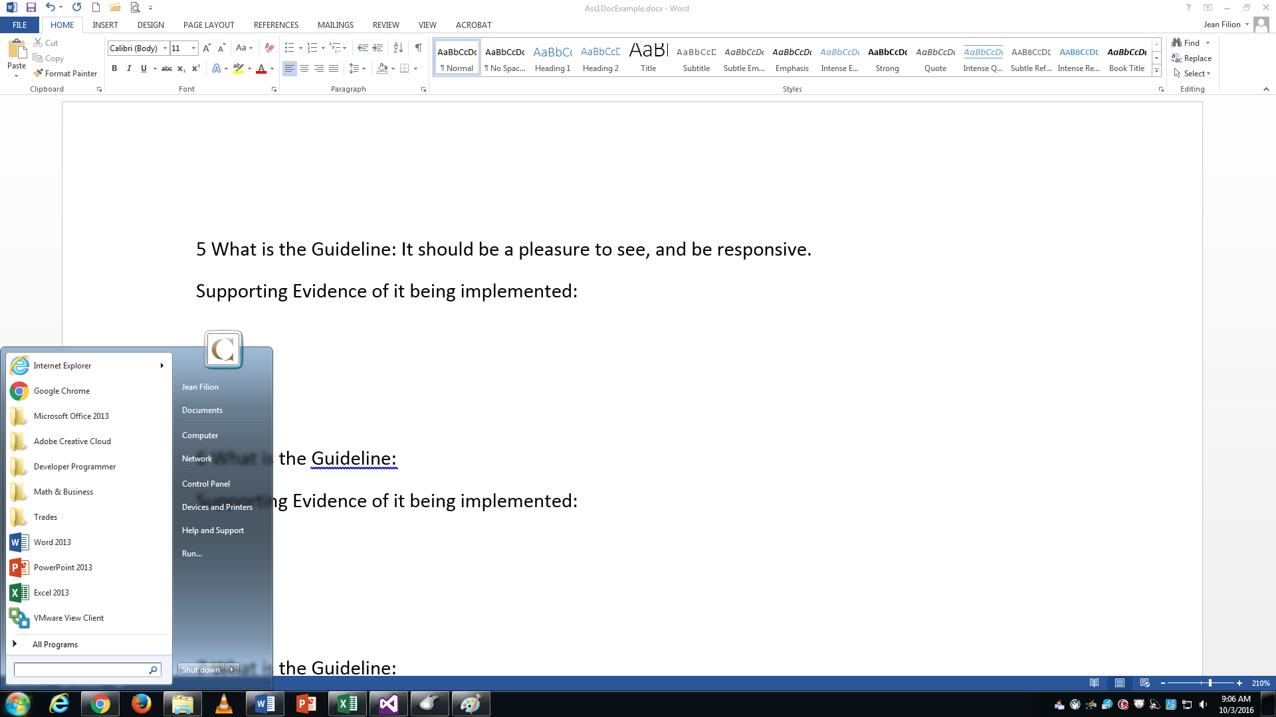

6 What is the Guideline: Use Keyboard Shortcuts for often used tasks.

Supporting Evidence of it being implemented:

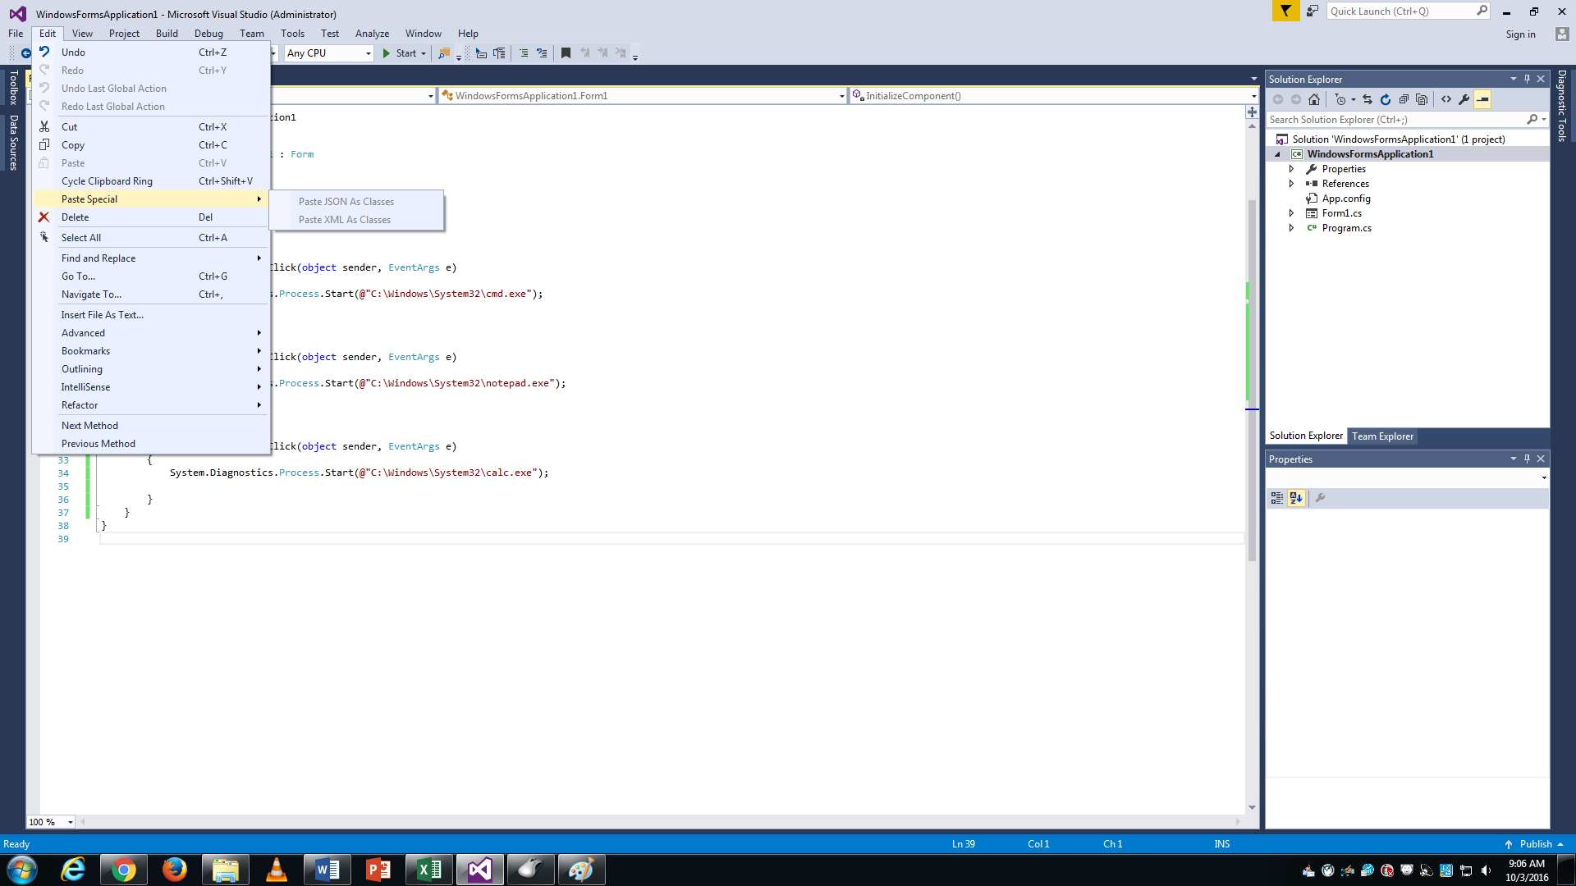

7 What is the Guideline: Use graphic elements to show hierarchy and relationships.

Supporting Evidence of it being implemented:

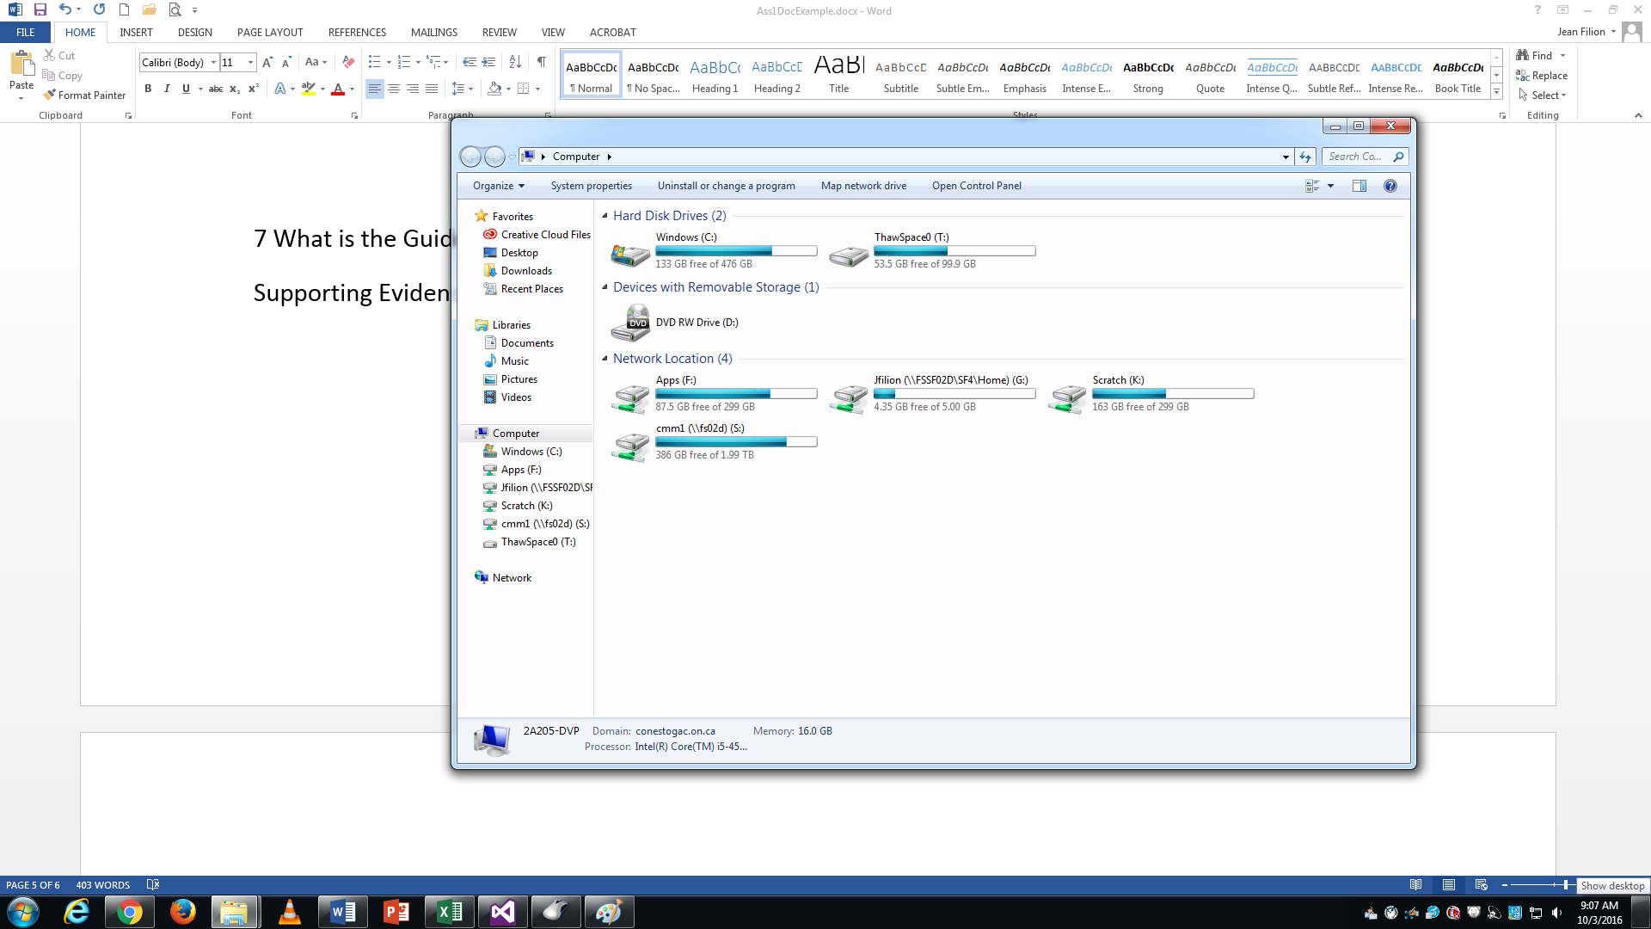

8 What is the Guideline: Keep icons simple. Two icons should not share functionality.

Supporting Evidence of it being implemented:

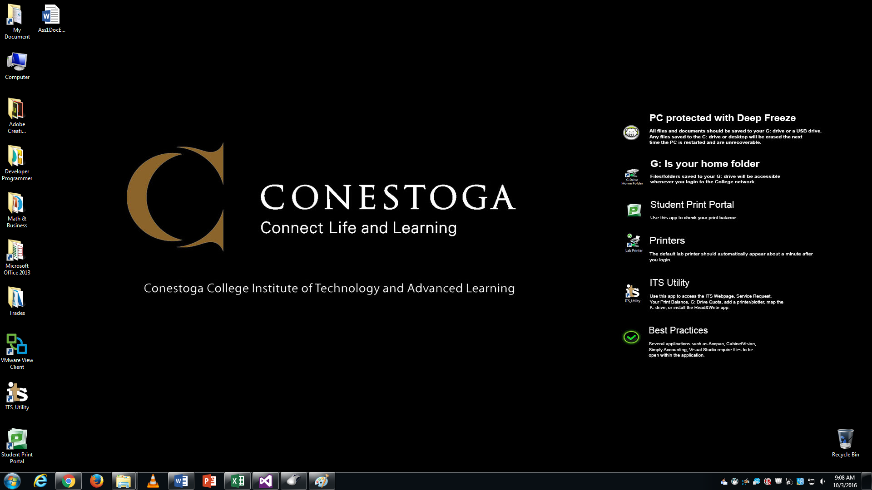

9 What is the Guideline:

Supporting Evidence of it being implemented:

10 What is the Guideline:

Supporting Evidence of it being implemented: